Central Limit Theorem:

Definition: The central limit theorem relies on the concept of a sampling distribution, which is the probability distribution of a statistic for a large number of samples taken from a population.

The central limit theorem says that the sampling distribution of the mean will always be normally distributed, as long as the sample size is large enough. Regardless of whether the population has a normal, Poisson, binomial, or any other distribution, the sampling distribution of the mean would be normal.

Scenario 1: Follows Normal distribution

X $∈$ N($μ, σ$)

Sampling Distribution of mean

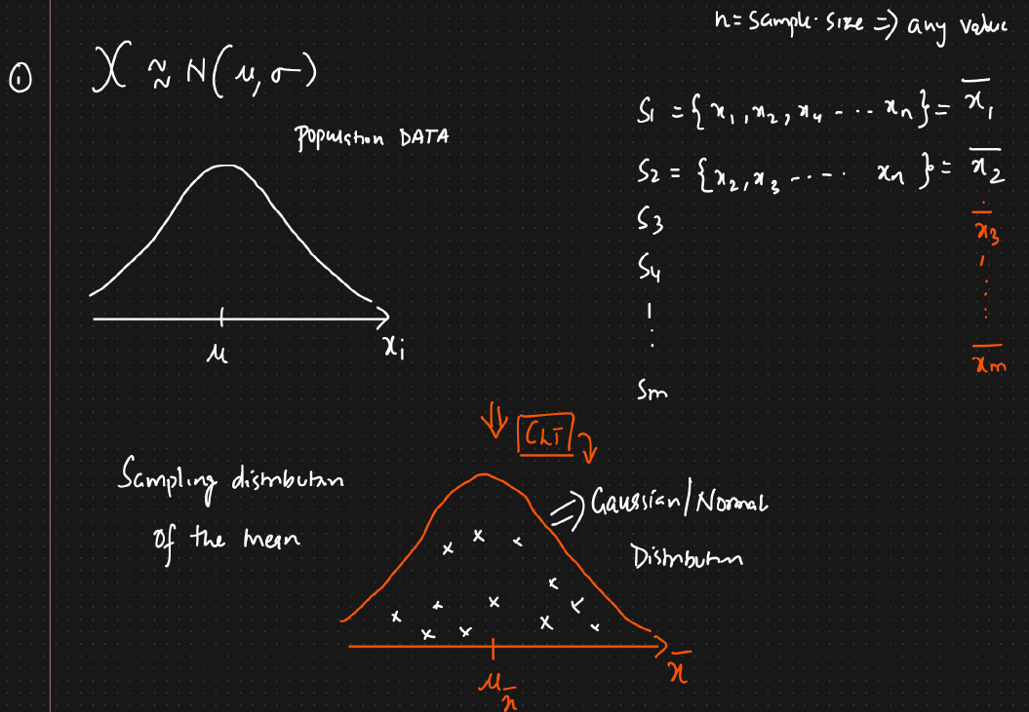



Scenario 2:

X does not belong to gaussian distribution

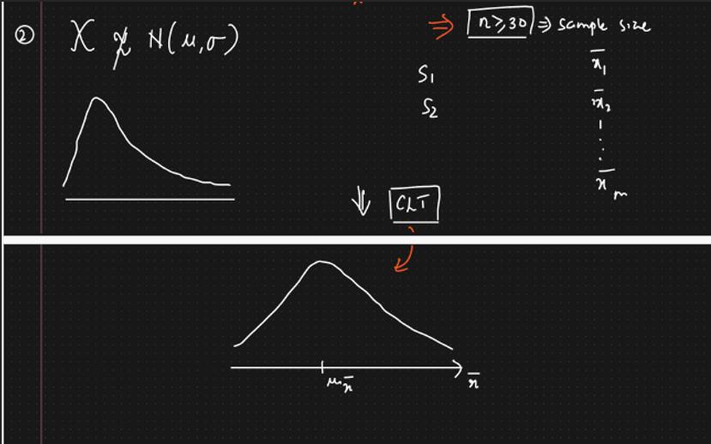

If X follows a gaussian distribution, then the n value can be any value

If X does not follow a gaussian distribution, then n should be greater than or equal to 30.

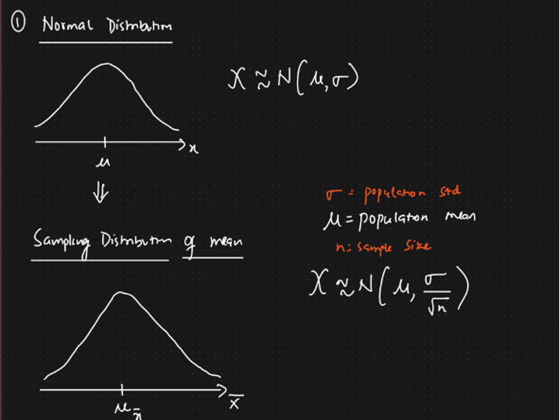

Mean will remain same.

Standard deviation will change.